

**EASTERN INTERNATIONAL UNIVERSITY**

**SCHOOL OF COMPUTING AND INFORMATION TECHNOLOGY**



**PETSHOP SALES WEDSITE**

**Trương Hoàng Vũ Duy - 1931209005**

**Trần Thanh Sang - 1931209006**

**Supervisors**

**Phạm Đại Xuân**

***Submitted for the Degree of Engineer in Software Engineering***

**May 25, 2024**

**EASTERN INTERNATIONAL UNIVERSITY**

**SCHOOL OF COMPUTING AND INFORMATION TECHNOLOGY**



**PETSHOP SALES WEDSITE**

**Trương Hoàng Vũ Duy - 1931209005**

**Trần Thanh Sang - 1931209006**

**Supervisors**

**Phạm Đại Xuân**

***Submitted for the Degree of Engineer in Software Engineering***

**May 25, 2024**

**May 25, 2024**

# ABSTRACT

The development of sales websites has evolved significantly, leveraging modern web technologies to create dynamic, user-friendly, and scalable platforms. After a period researching and discussing our group present a project building a sale pet website. The project discusses the development process of a pet sales website using React and MongoDB. React, a popular JavaScript library, facilitates the creation of dynamic, responsive, and user-friendly front-end interfaces. MongoDB, a NoSQL database, provides a flexible and scalable solution for managing the diverse data needs associated with pet sales, such as pet listings, customer information, and transactional records. Key features include cart, login, signup, and promo code, all integrated into a sale website designed for high performance and ease of use. This project will demonstrate full-stack development proficiency, combining modern Java-based backend technology with cutting-edge JavaScript frameworks.

# ACKOWLEDGEMENT

First and foremost, we consider ourselves fortunate to have the generous support and guidance of Mr. Pham Dai Xuan. We express our sincere gratitude to Mr. Pham Dai Xuan for his unwavering dedication and guidance across various aspects crucial for the successful execution of the project. Mr. Pham Dai Xuan has provided clear explanations, particularly in helping us comprehend the intricacies of the database and various data storage levels. With his invaluable assistance and our collective efforts, we have successfully developed an initial website with essential functionalities catering to both users and managers. While we acknowledge that there may be some limitations or oversights in our current implementation, we are fully committed to continuous improvement. Rest assured that we are actively working to address any shortcomings, and solutions to these challenges will be implemented in due course. We remain dedicated to enhancing our website and ensuring its optimal performance over time.

# TABLE OF CONTENT

ABSTRACT 4

ACKOWLEDGEMENT 5

TABLE OF CONTENT 6

CHAPTER 1 : INTRODUCTION 8

1.1 Company Overview 8

1.2 Feature of Project 8

CHAPTER 2 : TECHNOLOGIES 9

2.1 HTML 9

2.2 CSS 9

2.3 JAVASCRIPT 9

2.4 React 9

2.5 MOGODB 9

2.6 NodeJs 10

CHAPTER 3 : Proposed Approach, Analysis, Design, Implementation 11

3.1 Client View 11

3.2 View Cart Board 11

3.3 Signup 11

3.4 Home Page 11

3.5 Footer 12

3.6 Interface Design 12

3.7 Database Design 12

CHAPTER 4 : PRODUCT 14

4.1 Overview 14

4.1.1 Home page 14

4.1.2 Cat page 17

4.1.3 Dog page 18

4.1.4 Items page 19

4.2 Admin Panel 19

4.2.1 Add Product 19

4.2.2 Product List 20

4.3 Cart page 21

CHAPTER 5 : Conclusion and Future Works 21

5.1. Result 21

5.2. Drawback 22

5.2.1. Functionality aspect 22

5.3. Future Works 22

CHAPTER 6 : REFERENCES 24

# INTRODUCTION

## Company Overview

## Our mission is to connect pet lovers with their perfect companions through a seamless and enjoyable online shopping experience. We are dedicated to providing high-quality, healthy pets and comprehensive pet care resources to ensure every pet finds a loving home.

## Feature of Project

This project separate action for admin, registered users and unregistered users. Unregistered users can enter the Homepage website. Then they can view all pets, search pets by catalog, category in pet pages. They can put their wish item to the cart in cart page but cannot check out. Go to sign up page to create a new account. Registered users first enter homepage can also view all pets, search pets by catalog, category in pet pages. They can put their wish item to the cart in cart page without login and then sign in to checkout. Admin also can enter homepage and view all pets, search pets by catalog, category in pet pages. Especially, admin can enter a page called Admin Panel, a page that just admin users can log in. There, the admin can update the database of products, create a new pet, delete any pets, user accounts and order details.

# TECHNOLOGIES

## HTML

Hyper Text Markup Language (HTML) is a language for documents to be displayed in a web.

browser. It helps users to create and structure heading, body, footer, sections, paragraphs, links and blocks quotes for web pages and applications.

HTML is not a programing language.

However, it helps users to organize and format documents, similarly to Microsoft Word.[2]

## CSS

Cascading Style Sheets (CSS) is the language for describing the presentation of site pages, these include color, layout, and front. It also helps allows the site to adapt it presentation on different types of devices, from computers with large screens, to phone with smaller screens, from horizontal monitors to vertical monitors. CSS is independent of HTML and can be used with any XML-based markup language. The separation of HTML from CSS makes it easier to

maintain sites, share style sheets across pages, and tailor pages to different environments. This

is referred to as the separation of structure from presentation.[2]

## JAVASCRIPT

JavaScript is a scripting or programming language that allows you to implement complex features on web pages, every time a web page does more than just sit there and display static information for you to look at, displaying timely content updates, interactive maps, animated 2D/3D graphics, scrolling video jukeboxes, etc. JavaScript is probably involved in those function.[2]

## React

React is the most popular JavaScript library for building user interfaces (UIs). It gives excellent response speed when the user enters data using the new method to render the web page. The components of this tool are developed by Facebook. It was launched as an open-source JavaScript engine in 2013.

## MOGODB

MongoDB is a powerful, open-source NoSQL database renowned for its flexibility and scalability. Unlike traditional relational databases, MongoDB uses a document-oriented data model, allowing data to be stored in flexible, JSON-like documents. This schema-less design enables rapid development and iteration, as it can accommodate varying data structures without requiring extensive modifications to the database schema. MongoDB's horizontal scalability and distributed architecture make it an ideal choice for handling large volumes of unstructured data across multiple servers, ensuring high performance and availability. Its robust query capabilities, indexing, and aggregation framework further enhance its suitability for modern web applications, making it a preferred choice for developers seeking efficient and scalable data management solutions.

## NodeJs

Node.js is a software system designed to write scalable internet applications, especially web servers. The program is written in JavaScript, using event-driven, asynchronous import/export techniques to minimize total cost and maximize scalability.

The advantages of Nodejs:

- Fast processing speed thanks to the asynchronous processing mechanism (non-blocking). You can easily handle thousands of connections in the shortest amount of time.

- Make it easy for you to expand when you need website development.

- Receive and handle multiple connections with just one single-thread. As a result, the processing system will use the least amount of RAM and make the processing of Nodejs much faster.

- Ability to handle multiple Requests / s at the same time in the shortest time.

- Capable of handling thousands of processes for the most optimal performance.

- Suitable for building real-time applications such as chat applications, social networks ...

The disadvantages of Nodejs

- Nodejs is resource and time consuming. Nodejs is written in C++ and JavaScript, so processing needs to go through a compilation process. If you need to handle applications that consume CPU resources, you should not use Nodejs.

- Nodejs compared to other languages like PHP, Ruby, and Python will not have too much difference. Nodejs will probably be suitable for new application development. However, when building and implementing important projects, Nodejs is not the perfect choice.

# Proposed Approach, Analysis, Design, Implementation

## Client View

As a pet lover, I want to find and purchase the perfect pet online from the "Pet Shop" website to ensure a convenient and satisfying pet adoption experience at home. I'm greeted by the website with a welcoming and vibrant homepage that prominently features the company logo, stunning images of various pets, and an intuitive navigation menu.

Using the widget or adoption button on the homepage, I can easily navigate to the pet adoption page. The Pet Shop website boasts a user-friendly interface that allows me to browse through several categories of pets. I can explore the entire website, including relevant articles and resources, to find the exact type of pet I wish to adopt.

The website features an extensive range of pets, each accompanied by detailed descriptions, high-quality photographs, and a list of all the supplies available in the store. I can effortlessly see the full cost associated with each pet, including any adoption fees.

After completing my pet adoption, I receive a confirmation form with all relevant information, ensuring a smooth and reassuring adoption process.

## View Cart Board

As a user, when I choose a pet or items, I can easily to see the pictures, the information, the price, the description and the review. I also can add or remove the item, add the Promo code to have discount. It’s very easy to purchase.

## Signup

If the user does not have an account the can signup with name, email address, and password. The information will be saved on database. And when they login the information will be compared on database and authenticate the user on subsequent requests.

## Home Page

- Allows customers to view parts of the website.

- When they click on pets or items the products will be added to cart. User can click on cart icon to view page cart and pay for the products.

- On cart page user can remove the products that they do not want to pay, and they can also add the promo code to have discount.

## Footer

Short introduction about the pet shop.

Instagram

Contact

Like us

All right reserved

## Interface Design

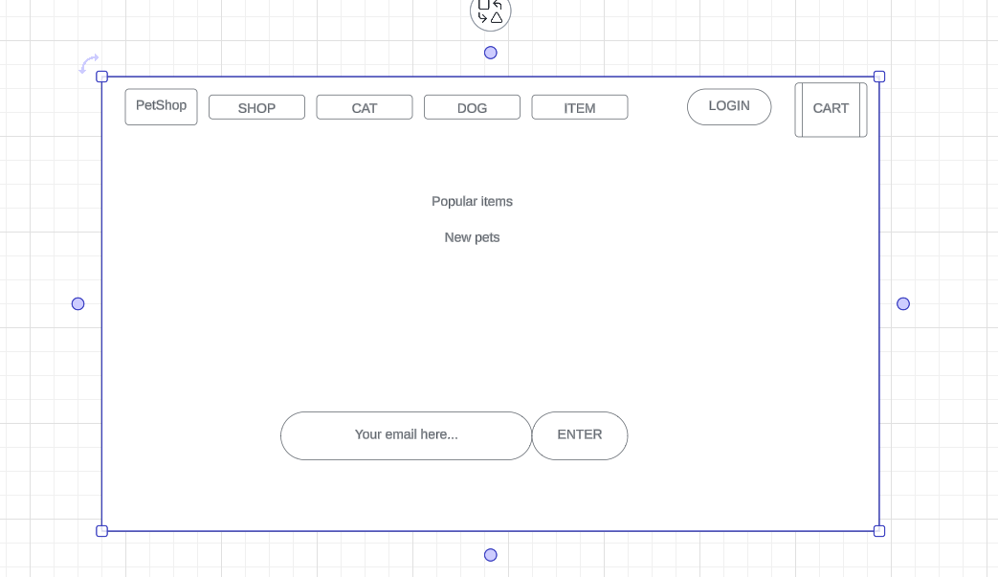

## Database Design

|  |  |
| --- | --- |
| **Name** | **Type** |
| Id | Number |
| Product | String |
| Price | Number |
| Location_id | String |
| remain | Number |
| imgURL | String |

# PRODUCT

## Overview

### Home page

Figure 14: HomePage(POPULAR ITEM)

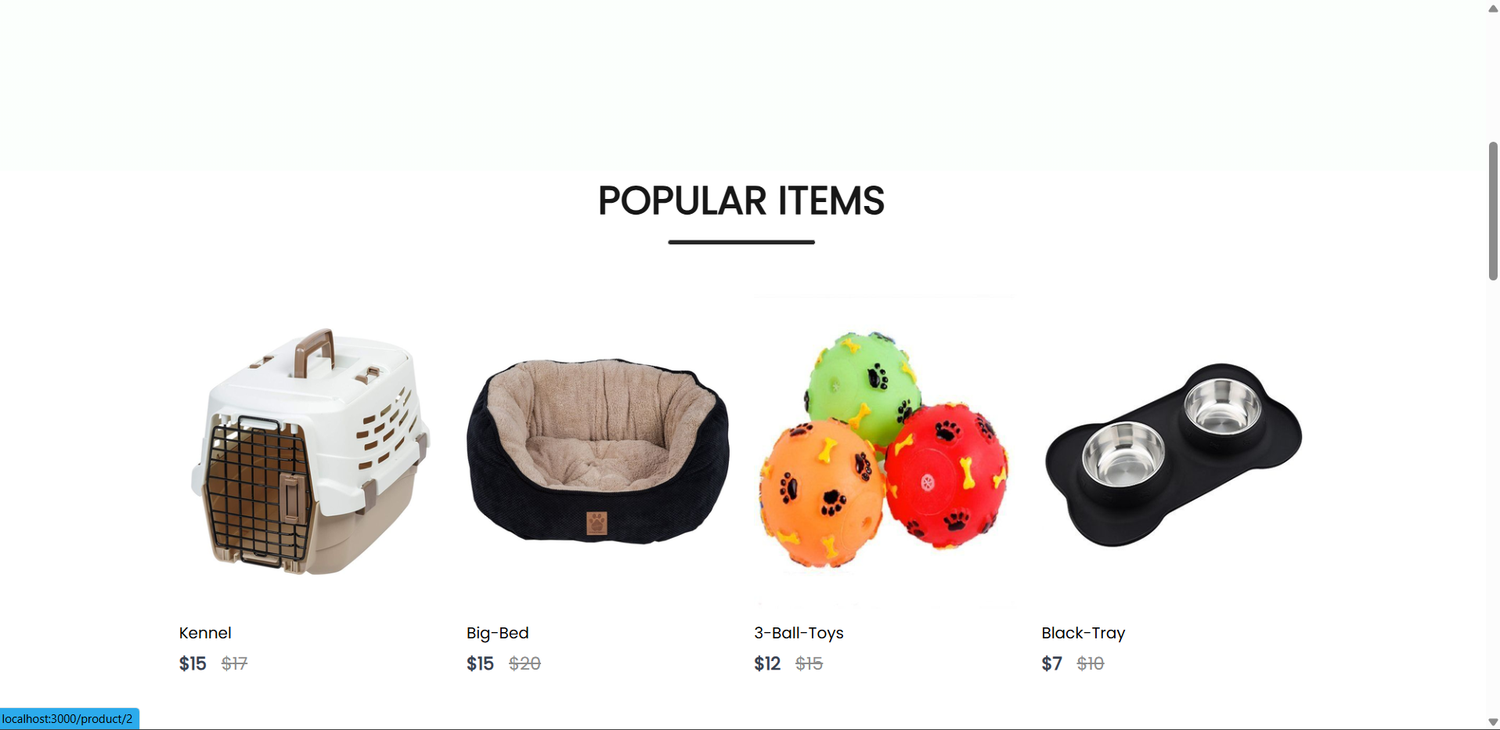

Figure 15: HomePage(2) new pets

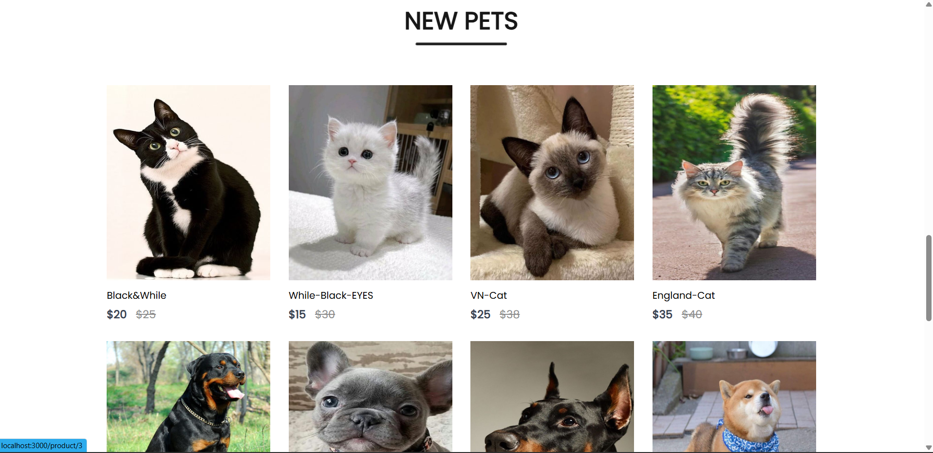

Figure 16: Log in email to get new in formation

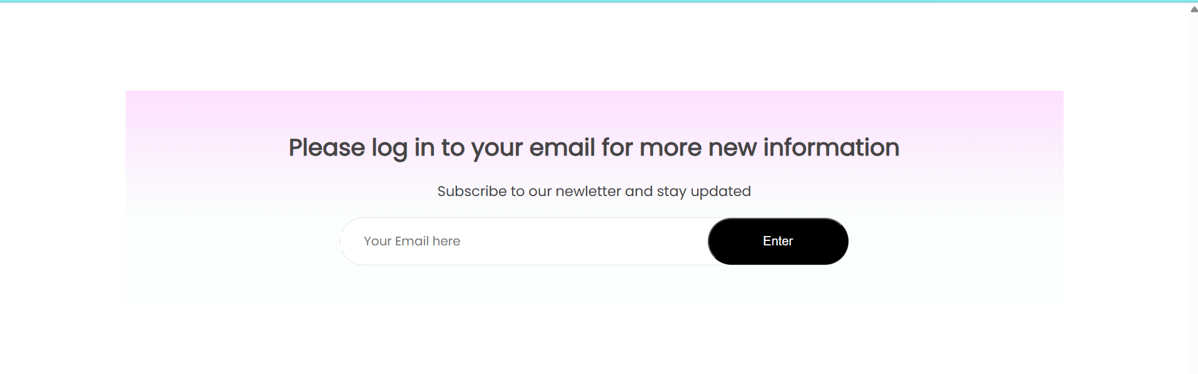

Figure 17: HomePage(3) about us site



### Cat page

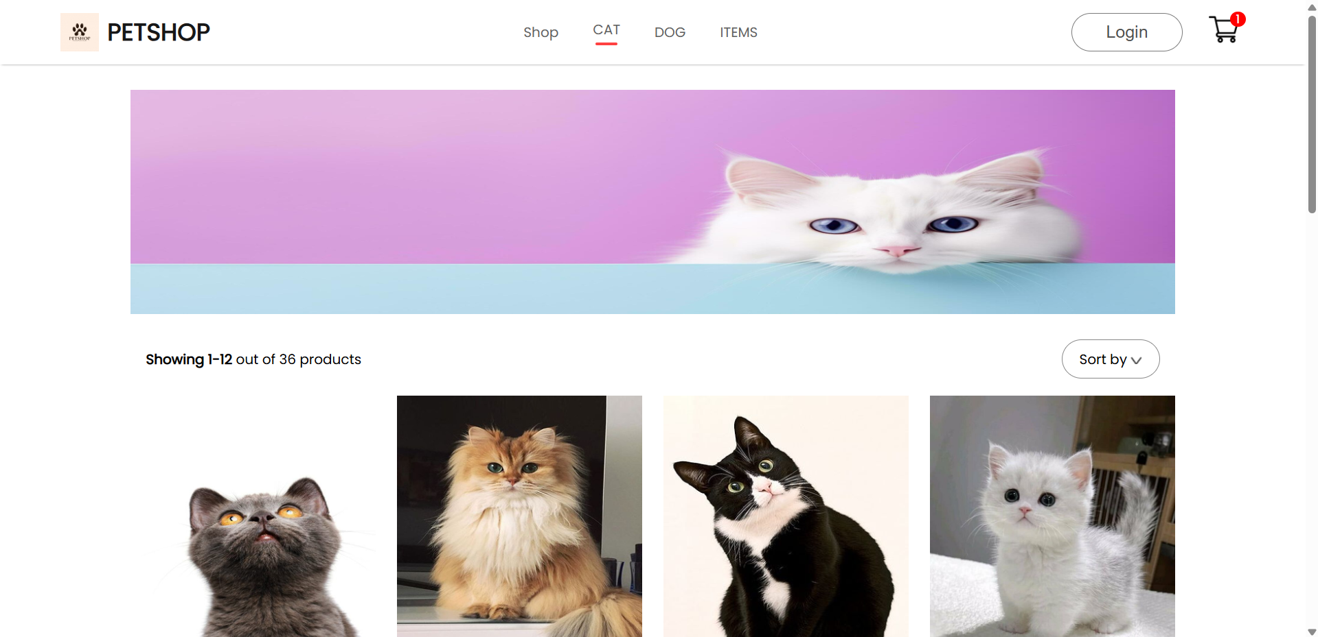

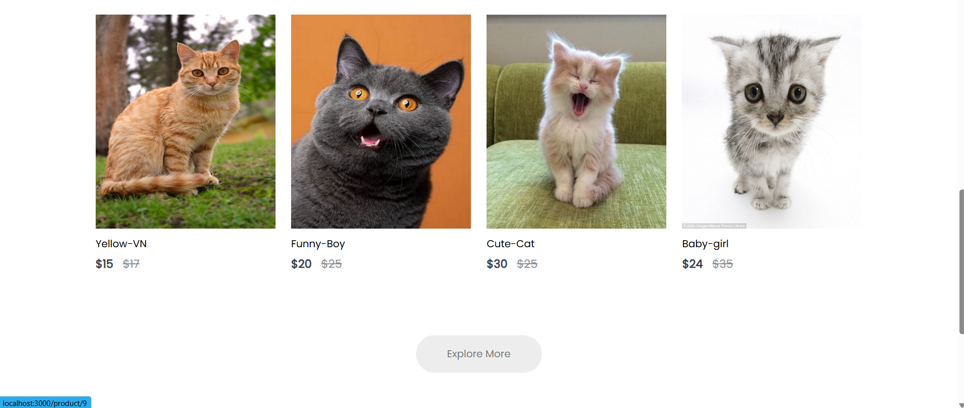

### Dog page

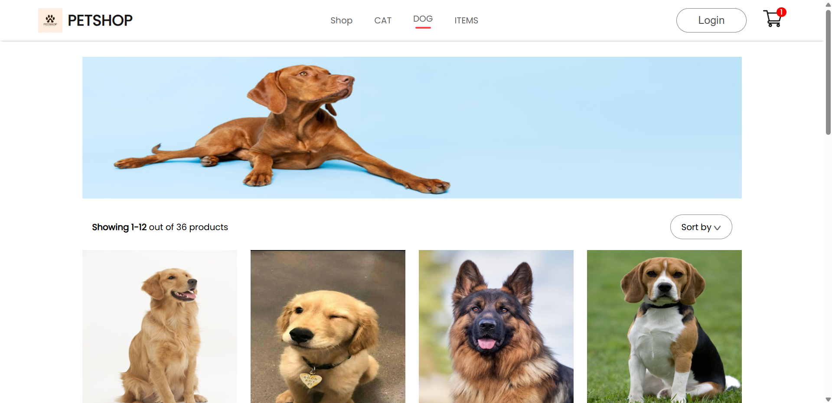

### 

### Items page

### 

#### 

## Admin Panel

### Add Product

Admin will add a new product:

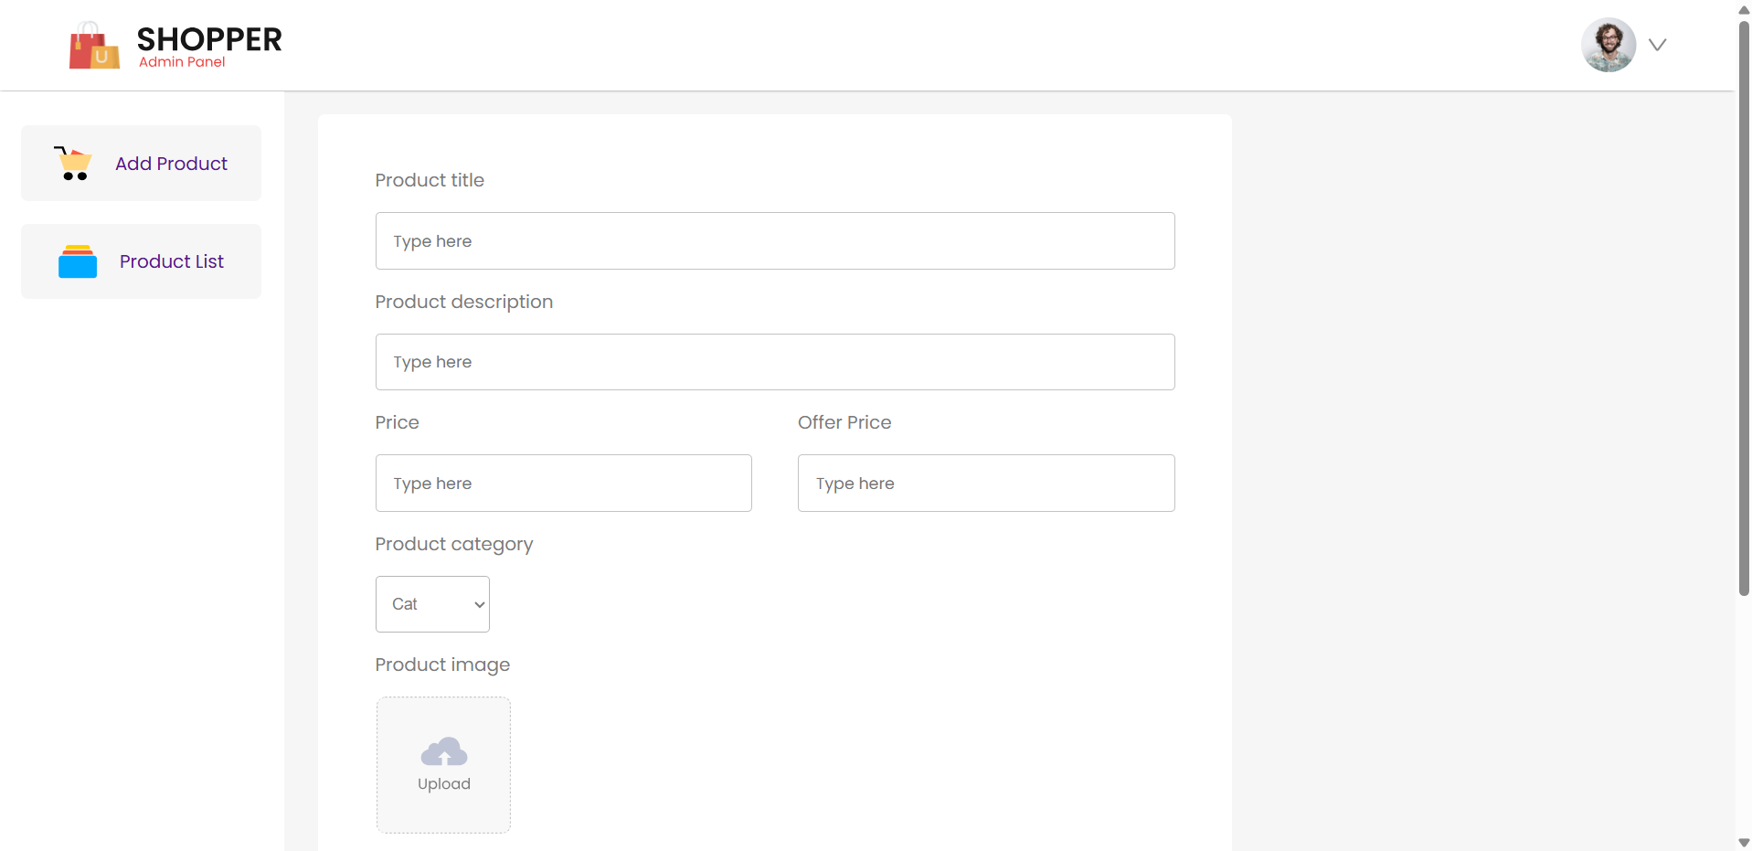

### Product List

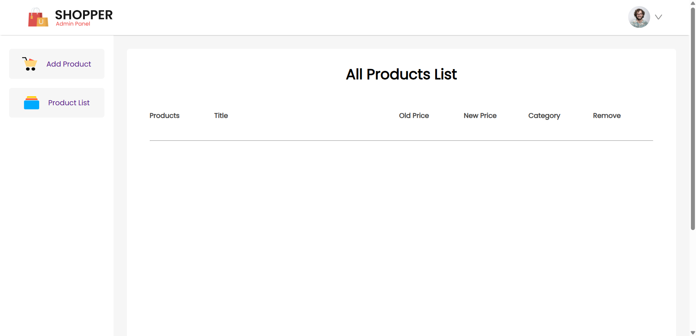

## Cart page

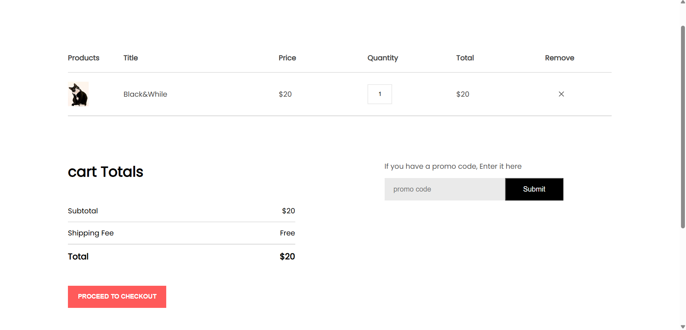

# Conclusion and Future Works

## 5.1. Result

After gaining valuable experience in technology and managing websites for various pet shops, I developed a "product management application and online pet shop website." This expertly crafted online pet trading and product administration program has significantly alleviated the time and effort required to manage the Pet Shop brand chain, creating advantageous conditions for the business. The application streamlines the purchasing process for customers, making it easier and more convenient for them to find and adopt their perfect pets.

The website offers the following features that are initially focused:

* Sign in
* Purchase items
* Pay for items

The program has offered the following fundamental features in accordance with the initial orientation:

* Save information of user when they signup.
* Add new feature of spa and grooming for pet.
* Remove products.

## 5.2. Drawback

One notable drawback of a pet shop website is the challenge of ensuring the welfare and proper handling of animals during the online purchase and delivery process. Unlike in-person transactions, where prospective pet owners can directly interact with and assess the pets, online platforms rely on digital descriptions and images, which may not always convey the pet's true condition and temperament. This can lead to misunderstandings and potential dissatisfaction. Additionally, shipping live animals poses significant logistical and ethical concerns, such as ensuring the animals' safety, comfort, and health during transit, which can be difficult to manage effectively through an online platform.

## 5.2.1. Functionality aspect

Absence of advanced search and filtering options: Customers are unable to customize their online experience on the website by filtering products based on specific parameters.

Limited payment options: At the moment, backend technology only accepts the most fundamental forms of payment. Increasing the number of payment channels and methods available, such as Zalo Pay, GooglePay, MoMo, and cryptocurrency-based systems, can boost user satisfaction and expand the clientele.

## 5.3. Future Works

Our future development roadmap is focused on enhancing the user's experience, improving backend functionality, and ensuring the security and integrity of our platform. To take our website to the next level, we will implement the following features:

* Advanced Search and Filtering: We will develop a robust search engine with faceted search and customized filters, allowing users to quickly and easily discover products that meet their specific needs.
* Expanded Payment Options: We will increase the number of payment gateways and options, including digital wallets, to provide customers with greater flexibility and convenience.
* Enhanced Customer Reviews: We will display more customer reviews concurrently with products, providing users with a more comprehensive understanding of our offerings and helping them make informed purchasing decisions.

To support our growing user base and improve the overall efficiency of our platform, we will:

* Optimize Mobile Responsiveness: We will ensure that our website is fully mobile-friendly by optimizing its responsive design and speed, providing a seamless user experience across all devices.
* Robust Security Measures: We will implement robust security measures, including secure authentication and encryption, to secure user information and protect our platform from online attacks.
* By focusing on these key areas, we are confident that we can create a more engaging, user-friendly, and secure online experience for our customers, while also improving the efficiency and effectiveness of our backend operations.

# REFERENCES

[1] “Full React Course 2020 - Learn Fundamentals, Hooks, Context API, React Router, Custom Hooks” https://www.classcentral.com/course/freecodecamp-full-react-course-2020-learn-fundamentals-hooks-context-api-react-router-custom-hooks-57817 (accessed: Jun. 24, 2024).

[2] “ReactJS Tutorial for Beginners: Learn with Step by Step Example.” https://www.guru99.com/reactjs-tutorial.html (accessed: Jun. 24, 2024).

[3] “Learn React | Codecademy.” https://www.codecademy.com/learn/react-101 (accessed: Jun. 24, 2024).

[4] “React Class Components.” https://www.w3schools.com/react/react_class.asp (accessed: Jun. 24, 2024).

[5] “React Components Lifecycle | ReactJS Training | Edureka | PPT.” https://www.slideshare.net/slideshow/react-components-lifecycle-react-tutorial-for-beginners-reactjs-training-edureka/80532295 (accessed: Jun. 24, 2024).

[6] “MongoDB Tutorial.” https://www.w3schools.com/MongoDB/ (accessed: Jun. 24, 2024).

[7] “Learn CSS Tutorial - javatpoint.” https://www.javatpoint.com/css-tutorial (accessed: Jun. 24, 2024).

[8] “Getting Started With ReactJS: A Complete Guide For Beginners.” https://www.geeksforgeeks.org/getting-started-with-reactjs-a-complete-guide-for-beginners/ (accessed: Jun. 24, 2024).